35.62: a) Since we can approximate the angles of incidence on the prism as being small, Snell’s Law tells us that an incident angle of on the flat side of the prism enters the prism at an angle of 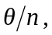 where is the index of refraction of the prism. Similarly on leaving the prism, the in-going angle is 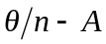 from the normal, and the outgoing, relative to the prism, is 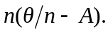 So the beam leaving the prism is at an angle of 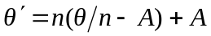 from the optical axis. So 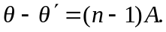
At the plane of the source 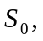 we can calculate the height of one image above the source: 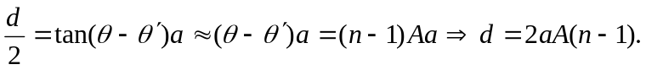
b) To find the spacing of fringes on a screen, we use:

